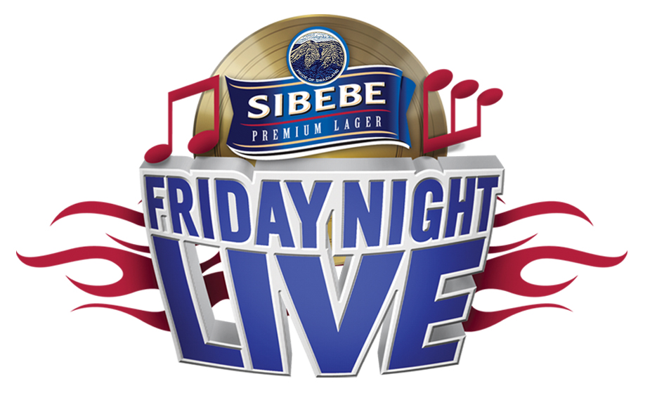

SIBEBE FRIDAY NIGHT LIVE
SEASON 7
Artist Application Form
(Artist Application Open From The 29th December 2017 – 31st January 2018)

ARTIST APPLICATION FORM:

Name of Artist:
Artist Manager:
Contact Cell:
Contact Email:
No. of Artists in band:
Genre/Style:
Artists Traveling From?

ARTIST REQUIREMENTS:
- Artist Biography Information (maximum 800 words) PDF
- Minimum 3 recorded songs. You may physically present songs on a CD with your application or attach the songs to your online application (Artists without recorded material will not qualify)
- Artists/Band Images (300dpi). Images must be maximum 3 and taken professionally or with a good quality camera phone. No Selfies.
- Tech rider and stage plan
- Any other special information or comments:

Please send your completed form to:
Email: sfnlsubmissions@gmail.com
FOR MORE INFO: +268 2528 2040
TERMS AND CONDITIONS
TERMS AND CONDITIONS
- Applicants must be 18 years and older
- Applicants must be residents of Swaziland
- Participants performers of Sibebe Friday Night Live 6th season cannot apply for season 7.
Participants of season 1-5 are welcome to apply to present NEW work and material.
- Artists must have recorded material
- Artists must have experience in live stage performance
**APPLICATION DEADLINE IS ON THE 31st OF JANUARY 2018, 4PM**

